Intelligent Computer Assisted Instruction in Thermodynamics
at the U.S. Naval Academy
Kenneth L. Tuttle

Chih Wu

Department of Mechanical Engineering
590 Holloway Rd
U.S. Naval Academy
Annapolis, MD 21402
wu@usna.edu

Abstract
Since 1996, the Mechanical Engineering Department of the U.S. Naval Academy has evaluated and incorporated Intelligent Computer-Assisted Instruction, ICAI, into the thermodynamics curriculum. The ICAI takes advantage of a new software package called CyclePad. CyclePad has been tested in three course and a forth course is scheduled for fall term 2001. Two other courses are in planning stages. The three courses to use CyclePad thus far include: EM319, Engineering Thermodynamics, a first term course for engineering students, EM443, Advanced Energy Conversion, an elective for mechanical engineers and EM300, Naval Engineering II, a core thermodynamics course for non-engineers. Testing the software in these courses has caused improvements to be made to the software as well as evaluating student receptiveness of a computer-based approach to thermodynamics. This testing judged compatibility of the course material with the ICAI approach. Improvements included increasing user friendliness of CyclePad. This effort was concurrent between Computer Science Professor Kenneth D. Forbus and the software development group at Northwestern University and Peter D. Whalley at Oxford University and Professor Chih Wu at the U.S. Naval Academy. These efforts successfully integrated CyclePad into the classroom as a tool for design and research as well as teaching. This paper describes the courses, students targeted, logic of planning approach and long-range goals at the U.S. Naval Academy. The paper presents a study of effectiveness of CyclePad and also current and planned course developments.

Introduction
College and university engineering programs encounter increasing difficulty providing graduates the amount of knowledge that employers demand. In that vein, ICAI, Intelligent Computer-Assisted Instruction offers an opportunity for instructors to find more effective methods for teaching engineering. Mechanical Engineering faculty at the U.S. Naval Academy tested Intelligent Computer-Assisted Instruction in existing courses and developed an elective course, including a textbook, for full immersion in computer-based thermodynamics.
Intelligent Computer-Based Thermodynamics is the instruction that is being advanced by this research. A sophisticated software package named CyclePad forms the computer basis for the ICAI testing and course developing in these efforts. CyclePad not only reduces the time spent doing hand computations, the software also requires students to learn how to define processes and states. Students gain a feel for the significance of concepts and then learn how to solve the problems that are associated.
Since thermodynamics is a basic, problem-oriented course, students must practice finding properties and analyzing thermodynamic devices. Students analyze thermodynamic cycles in order to understand the concepts in thermodynamics. Finding properties and actually calculating thermodynamic devices by hand are lengthy, complex, tedious tasks for a student. Analyzing devices is more meaningful. Time is saved.
It is fun for students to use quick simulation software such as CyclePad. Students are able to change any parameter and see the effect on performance of the device. Due to the quick response of CyclePad, instructors are able to teach more material and assign more difficult problems. Design projects that cannot be done by hand calculation are possible using CyclePad. Often, calculations cannot be done by hand owing to time constraints. Of even greater importance, the artificial intelligence potential of a sophisticated software package such as CyclePad adds the capability of an instructor and a textbook. In this case, CyclePad offers a ‘Coach’ capability that helps the students where they lack knowledge or simply make mistakes. The ‘Contradiction Mode’ of CyclePad keeps a student from designing a system that defies the laws of physics. The AI capabilities of CyclePad tell the students when they have built a complete cycle or a complete process, one having a ‘source’ and a ‘sink’ or a ‘begin’ and an ‘end’. When they begin to analyze a system, CyclePad checks that working fluids, ideal processes and properties such as temperatures and pressures are free of contradictions.
The importance of having an expert check the students’ work as they go cannot be overstated. The students get more done and learn more for three reasons. First, students get more done because CyclePad does the laborious calculations for cycle analyses. Students analyze the cycle rather than learning to make the calculations one time.
Second, students are able to complete complex designs that exceed their knowledge level because CyclePad checks their work as they go. It is vital to students’ educations that they analyze designs that are error free. It is counter-productive in the extreme if students learn facts based on erroneous assumptions. This is where ICAI cannot be equaled.
The third reason students learn more thermodynamics using a computer-based approach is because CyclePad has sophisticated analysis and graphing capabilities. Any system a student successfully designs may be used to conduct a sensitivity analysis. CyclePad allows students to vary any parameter and plot the results of any parametric analysis. Students learn more because they do more. They can easily run experiments and analyze results using CyclePad. The software is user-oriented and tends to be a self-learning tool.

History

CyclePad
CyclePad is an articulate virtual laboratory (AVL) written to create and analyze thermodynamics cycles. An AVL is a software program that can make conceptual design tasks possible for students and explain or demonstrate how and why. CyclePad was developed for university engineering students.
CyclePad was developed in the mid 1990’s at Oxford University by Peter D. Whalley and at Northwestern University by Computer Science Professor Kenneth D. Forbus and several computer science Ph.D. Candidates plus one in mechanical engineering and one in education. The software was tested by engineering faculty at Northwestern and Oxford and at the University of Arkansas at Little Rock and the U.S. Naval Academy (Baher, 1998).
Soliciting email questions and reports of problems as users encounter them effects continuous improvement. The process is easy and improvements are reflected in semi-annual upgrades to the software. The software is disabled until the latest upgrade is downloaded from the web. Most improvements were made during the first few years of testing, however, new users stretch the software to new uses and progress continues. Questions are answered promptly. Computational errors or problems that are reported with the software are slower because they require examination to determine validity and the solving.

Testing CyclePad
Several years of testing CyclePad at the U.S. Naval Academy continues by Professor Chih Wu. Dr. Wu tested CyclePad from early in its development and continues to use CyclePad in test sections of two thermodynamics courses and one engineering-elective. One thermodynamics course and the elective are offered to ABET accredited engineering majors. The other thermodynamics course was developed at the Naval Academy about 1970 for non-engineering majors. More recently Dr. Wu has moved to establish one or more courses to use CyclePad on a dedicated basis.
Testing began in the mechanical engineering course, EM319, Engineering Thermodynamics, the only first term thermodynamics course at the Naval Academy for engineers. The department does offer a second term course, EM320, but only to mechanical engineering students and it has not been taught using CyclePad. EM319 is a required course. It covers thermodynamic concepts, definitions, thermodynamic properties, energy, work, heat, entropy, first law, second law, ideal power cycles, heat pump cycles and refrigeration systems. The annual enrollment is about 400. EM320 has only about 100 students. Either EM319 or EM320 would be good choices for use of Intelligent Computer-Assisted Instruction, ICAI. CyclePad is designed for these types of courses, especially EM320, the applied thermodynamics course.
At the Naval Academy, there is another thermodynamics course, EM300, Naval Engineering II, for students in non-engineering majors. EM300 has been tested and is very suitable for using CyclePad. This course covers basically the same subjects as EM319 and EM320, but at a less challenging level. Students are required to understand thermodynamic principles and their applications. EM300 enrolls 650 to 700 students each year. This course is targeted in two approaches. The one in use is to have special sections that use CyclePad to solve some of the cycle problems. The second and ideal, is to have a special version, EM300C, with several sections in a dedicated CyclePad course with as many problems as possible worked using CyclePad.
A third course is EM443, Energy Conversion. It is an elective for mechanical engineers and has only one section. The course covers non-conventional power, heat pump and refrigeration systems analyses and design. In EM443, students used CyclePad to work on complex problems as part of a term paper. (Wu, 1997)

Results
During ten semesters at USNA, Prof. Wu found that using CyclePad helps students visualize, simulate and design thermodynamic devices better than conventional instructional methods. CyclePad introduces students to the concept of design, an open-ended process, and makes learning thermodynamics more exciting. The result is more effective training of future naval officers and engineers.
The experience has been a positive one. Student questionnaires that were prepared to solicit student evaluation of CyclePad have produced generally positive feedback. There were several tasks that most students thought were hard to accomplish, such as printing a schematic or diagram. Most thought is was easy to input data and save files and were evenly split on getting output values, translating word problems to diagrams and understanding system irreversibilities.
Most students thought the software was easy to learn and that their training on the software was at about the right level. One student who missed class that day answered that he did not feel at all trained on the software. Almost all thought the concepts were similar to their textbook. Nobody said they ‘frequently’ used the software to help with homework, although several said they did occasionally. Most used CyclePad only when it was assigned. The students in EM443 were evenly split on whether they used CyclePad on their PC’s or just used it in the computer classroom. Most felt CyclePad helped them to understand thermodynamic systems well or well enough, but quite a few gave negative responses.
The most interesting responses were the written answers to questions 14 and 15 regarding ways to improve the software and what types of bugs they found. For example:
14. What improvements would you make?
Include fluid losses.
Need to be able to manually recalculate when changing values.
Make available on PC’s.
Easier printing with information boxes open.
Better troubleshooting for inconsistencies,
Make a manual.
Need more memory.
Print Properties.
Need easier Printing, add Print Screen feature.
15. What types of ‘bugs’ have you experienced?
Iterations are lengthy.
Printing is easy in the electronic classroom; printing is hard in the student’s room.
Software shuts down.
Cannot input net power.
Loss of memory is too frequent.
Will not print properties.
It is difficult to get the software to solve a problem. Freezes easily.
Printing a schematic freezes the system. Must save and restart owing to memory space. Hard to understand why a design does not work. Program stops working sometimes.
Saves information wrong sometimes.
Responds incorrectly sometimes.
Changes values some times.
Does not do the calculations sometimes.
These are all valid points and some of them would be difficult to detect without the student feedback. For example, the fact that printing is easy in the classroom but difficult on the student’s PC is subtle but critical. Some of the memory problems may be owing to different PC capabilities. Some of the errors the software introduces such as saving incorrectly and failing to make calculations when requested are such subtle errors that detecting them requires luck or many users. It is reassuring also, to hear that the software worked well, except for the printing.
On a different note, testing produced results only on courses that are not dedicated to CyclePad solutions. Furthermore, both of the thermodynamics courses tested were multi section courses with only partial control by the instructor testing CyclePad. Several constraints exist to using CyclePad to its full potential in existing courses. For example, following the same syllabus as non-CyclePad sections prevents rearranging the sequence of topics as desired for CyclePad sections. A CyclePad course introduces cycles early in an introductory thermodynamics class. In addition, mixing sections forces a CyclePad course to use the same homework problems and examinations as existing courses. Furthermore, current textbooks do not adapt to teaching with CyclePad.

CyclePad

Contents
CyclePad is intelligent computer software that was co-developed and evaluated by Prof. C. Wu in the Mechanical Engineering Department at the U.S. Naval Academy (USNA) with Oxford University and Northwestern University since 1995. The software has been used in several thermodynamic courses at USNA for multiple semesters. CyclePad is designed to help with the learning and conceptual design of thermodynamic cycles. The software is designed to operate in three phases, build mode and contradiction and analyze mode. Refer to “Intelligent Computer Aided Optimization of Power and Energy Systems” (Wu, 1999) for more information on using CyclePad.
Professor Forbus, Northwestern Computer Science Department, is one of the co-authors of CyclePad. He describes CyclePad as a virtual lab. Articulate Virtual Laboratories (AVL’s) are software programs that can make conceptual design tasks more accessible to students. An AVL may also provide explanations of how and why for the scientific principles used. CyclePad was designed to teach thermodynamics by allowing students to design, build and analyze all of the thermodynamic cycles that are commonly taught to undergraduates (Baher, 1998).

Modes
Build Mode is the first step. A user takes components from a thermodynamic inventory to form a thermodynamic cycle. Alternatively, a state or a process may be formed.
Analyze Mode is second. A user must choose a working fluid from the menu, assume a process for each component, and input numerical property values such as known temperatures. The software then does all the calculations. In addition, a sensitivity analysis may be used that makes cycle performance and the effect of a parameter variation both quick and easy to see. It also may be used to generate plots to show the effect in graph form.
Contradiction Mode is activated automatically any time a user creates a contradiction while defining the parameters for analysis. For example, if the phase of matter is given as vapor when it needs to be liquid to avoid a contradiction, CyclePad displays a help screen that explains that a contradiction has been created and lists all of the relevant analysis parameters.
Coach Mode is an instructor in the software. Coach activates whenever the user makes a mistake, a contradiction or a request. The coach will explain the contradiction and suggest ways that the contradiction may be resolved. At any time, a student may request the Coach’s assistance.

Limitations
Several constraints to using CyclePad’s full potential do exist. Using a common syllabus in special sections, that are CyclePad sections, prevents rearranging the sequence of topics. Introducing cycles as early as desired may not be possible. In addition, CyclePad sections are forced to use the same homework problems and examinations as the conventional sections.
A second limitation is textbooks. A conventional textbook does not adapt well to working with CyclePad. To integrate CyclePad into thermodynamics courses, instructors may want to re-sequence the material and have homework problems designed for CyclePad. The objective is to shift the course emphasis from paper-and-pencil problems to general, more-basic problems and design problems.
An experimental thermodynamics course would be better. An instructor may develop new curriculum. This is often necessary when trying innovative problems with students. Such a class would be significantly different from a traditional course and yet still emphasize teaching the same basic principles. The main difference is the focus. It would be design based and more applied. CyclePad software should be used to give students a better understanding of thermodynamics and give them an early start in the design experience. Also needed are experimental courses to create curricular supports such as instructor materials. Such materials might include challenging homework exercises and examinations that will help students better learn and understand concepts. Other professors need these materials. All contributions will help faculty integrate CyclePad into future teaching practices.

Systematic Approach to Cycle Analysis
CyclePad can analyze several different thermodynamic cycles that model heat engines. Each heat engine has a cycle that models it most closely, although never perfectly. A cycle has a working fluid that is heated and cooled, expanded and compressed. The most common working fluids are air and water. In addition, a heat engine includes a compressor or pump to raise the pressure of the working fluid, a heat exchanger or heater to transfer heat from the heat source to the working fluid and an expander to produce work. Finally, a cycle needs a heat exchanger or cooler to reject heat from the working fluid to the heat sink even though the working fluid in an internal combustion engine exhausts to the heat sink.
CyclePad takes a systematic approach to the analysis of heat engine cycles. Students select one of two basic categories of heat engines, the open system type or the closed system type. The open system type includes all heat engines that involve the working fluid flowing steadily through the engine. The closed system heat engines include those with one or more non-flow processes such as constant volume heat addition or rejection. All reciprocating engines (piston and cylinder) are modeled with constant volume heat rejection. In the closed system, mass is controlled.
Included in each category are two or more types of heat engines that have different types of working fluids or different processes modeling heat addition, compression and expansion. The working fluid and the type process involved are selected in the analysis mode. The arrangement of the compressor/pump, heater/heat exchanger, expander and cooler is produced in the build mode. The student or engineer may go back and forth between the build and analyze modes but would normally build a heat engine and then define the parameters in the analyze mode. If any inconsistencies develop, the mode switches automatically to the contradiction mode until the author corrects the contradiction. This is a form of artificial intelligence built into CyclePad that serves as a coach or instructor for the student.
When building is complete, analysis of the cycle is completed automatically. The efficiency and work of the cycle may be viewed immediately. By taking a step further, a student may conduct a sensitivity analysis of the heat engine by varying any parameter desired and CyclePad will plot the results of any experiment very quickly and easily.
The reason for modeling heat engines with thermodynamic cycles is for ease of analysis. Cycle analysis may be easier by hand than by analyzing an engine. However, analysis is still laborious compared to using a computer to model and analyze the cycle. CyclePad was developed with these needs in mind.
CyclePad Example Problem
CyclePad may be used to solve and analyze heat engine cycles as well as heat pump cycles and refrigeration cycles. The ideal cycles may be analyzed or component efficiencies may be included to form an actual cycle. Thermodynamic systems are classified as closed systems, such as reciprocating engines, and open systems, such as gas turbines and steam turbines. Thermodynamic cycles for heat engines are classified as closed cycles if the working fluid is recycled, such as steam or other Rankine cycles, most refrigeration cycles, and theoretically, the Brayton cycle, although it is unusual. Cycles are open cycles if the working fluid is not recycled, such as internal combustion engines that must exhaust the working fluid. This category includes most heat engines, both reciprocating engines and gas turbine engines.
The most important heat engine on navy surface ships and all navy aircraft is the gas turbine engine. Gas turbines may have a single compressor and a single turbine on a single shaft if the load does not need to change speed as in a generator or a pump. Split-shaft gas turbines are more common for propulsion. Here, the engine has two turbines and one compressor. One turbine is on a shaft with the compressor and powers it. The second turbine is on a shaft to the reduction gear and propeller.
The example problem is a split-shaft gas turbine with parameters matching the LM2500 gas turbine used by the navy on surface combatants. To demonstrate sensitivity analysis of the Brayton cycle that models the gas turbine engine, an ideal Brayton cycle and an actual Brayton cycle are analyzed and compared to each other and to the split-shaft gas turbine analysis as the temperature of the gas entering the turbine is increased.
Figure 1 is the split-shaft gas turbine as it appears on CyclePad after the components have been assembled in build mode. Because it is being modeled as an open cycle, a source and a sink are needed to provide the working fluid flow in and out. A heater is used to provide heat input to the working fluid is air, and a cooler is needed to account for the heat rejected when the working fluid is exhausted.
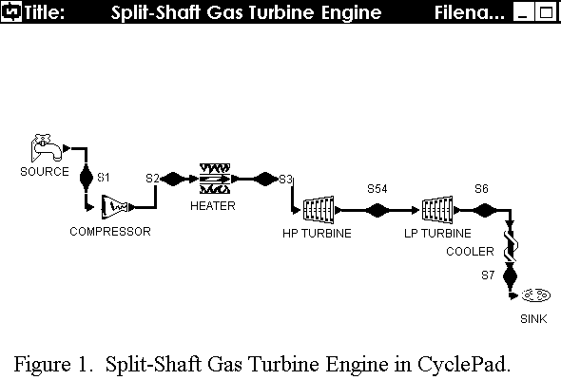
Finally, two turbines and one compressor complete the components. The components connect by ducting and the state of the working fluid may be assumed or calculated at each state point. The turbine that receives the hot, high-pressure gases from the combustor (heater) is the high-pressure turbine. The second turbine is the low-pressure turbine. The state point between the turbines is labeled S54 because that matches the designation used for that point on the LM2500.
When a design is complete and correct, such as Figure 1 is, CyclePad says so and asks if the student wants to move to analysis mode. In the analysis mode, a working fluid and fluid properties must be specified. In addition, mass flow rate of the working fluid is assigned and assumptions for all processes, including component efficiencies, are made until the cycle is completed. If any erroneous assumptions are made or if two are in contradiction with each other, CyclePad catches the error, stops the analysis and prompts the student to make changes until the contradiction is eliminated.
To make assumptions, a menu appears if the mouse is clicked on any component or any state point. Figure 2 is the split-shaft gas turbine shown in Figure 1, but with all of the state points showing a list of the working fluid properties at that point. In this example, the initial and final temperatures and pressures were entered as assumed values as was the temperature of the gases entering the high-pressure turbine. These are common assumptions for a straightforward Brayton Cycle problem. In addition, the pressure ratio is assumed for the compressor and the work of the high-pressure turbine is assumed to be equal to the compressor work, absolute value. Figure 3 shows the components and the calculated values for the energy change in each component. Work in is shown as negative; heat in is shown as positive. In a heat engine, the objective is to put heat in and get work out. The over all cycle performance, such as efficiency and power, is also calculated by CyclePad and is shown in one meter. The next step in the analysis is to plot the temperature-entropy diagram or run a sensitivity analysis on the design.
The variable that the Brayton Cycle efficiency is most sensitive to is the pressure ratio. For the Otto and Diesel Cycles it is the compression ratio. These are essentially the same thing since the pressure ratio is equal to the volume ratio to a power. Whichever one is known may be used. Figure 4 is a plot showing the how sensitive the ideal Brayton Cycle is to changes in the pressure ratio. The ideal cycle assumes each component has no losses; therefore the cycle thermal efficiency is higher than reality. Figure 5 is closer to reality. Figure 5 is the same analysis and sensitivity analysis of the actual Brayton Cycle. The shape of the actual Brayton Cycle efficiency curve is similar to the ideal Brayton Cycle in Figure 4, but the values are lower.

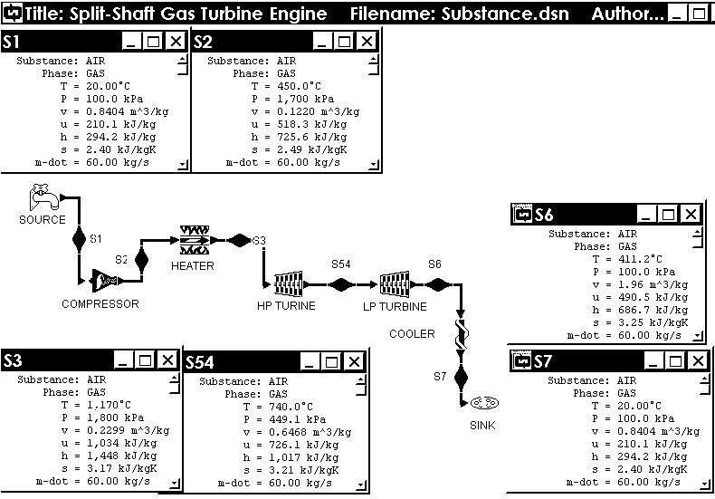

Figure 2. Substance Properties at State Points in a Split-Shaft Gas Turbine.

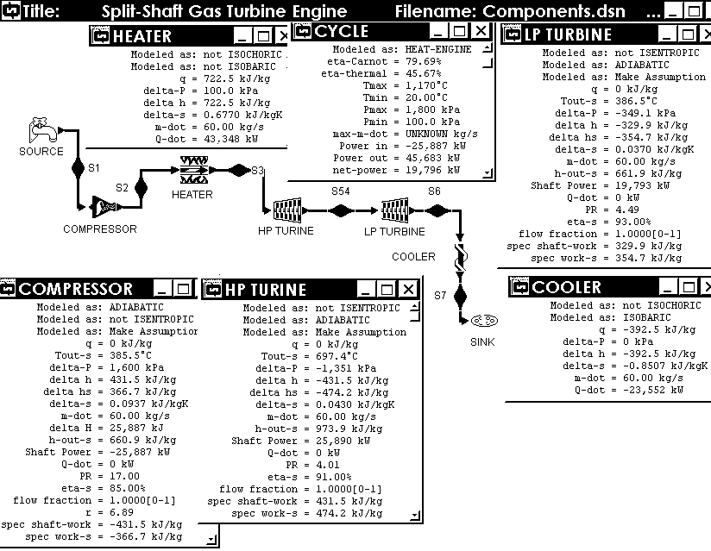 Figure 3. Component Properties in a Split-Shaft Gas Turbine Engine.
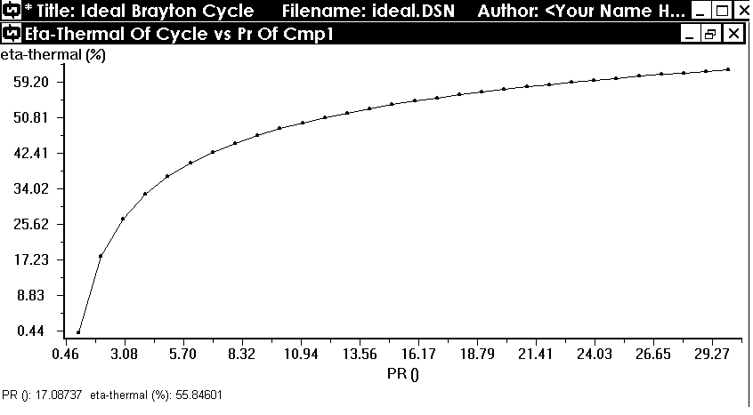 Figure 4. Effect of Pressure Ratio on Cycle
Efficiency in an Ideal Brayton Cycle.

The variable that is least understood and that this use of a computer program improves instruction is shown in Figures 6 and 7. Figure 6 is a plot of the effect the temperature of the heat source (or, temperature of the working fluid entering the turbine) has on cycle thermal efficiency in
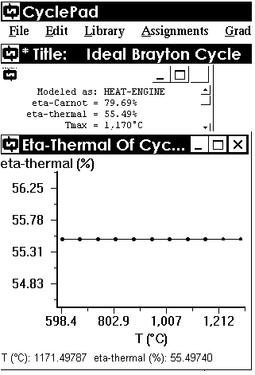
Figure 6. Effect of Source Temperature on Cycle
Efficiency in an Ideal Brayton Cycle.
the ideal Brayton Cycle. The students are confused on this one because in physics they learned that only two things affect the efficiency of the Carnot Cycle, the temperature of the heat source and the temperature of the heat sink. While that is true for the Carnot Cycle, it is not true for any cycle that is not totally reversible as is Carnot. Figure 6 shows this clearly. Increase the temperature of the heat source, no change in efficiency.
To add to the confusion, gas turbine manufactures strive to push maximum gas temperatures higher and higher and the gas turbines get more efficient as they do. For the answer, look at an actual Brayton Cycle. Figure 7 is the same Brayton Cycle as shown in Figure 6 and shares the assumptions used in the split-shaft example in Figure 3. Figure 7 shows that as the temperature of the heat source is increased in an actual Brayton Cycle, the cycle thermal efficiency increases. It is caused by the component
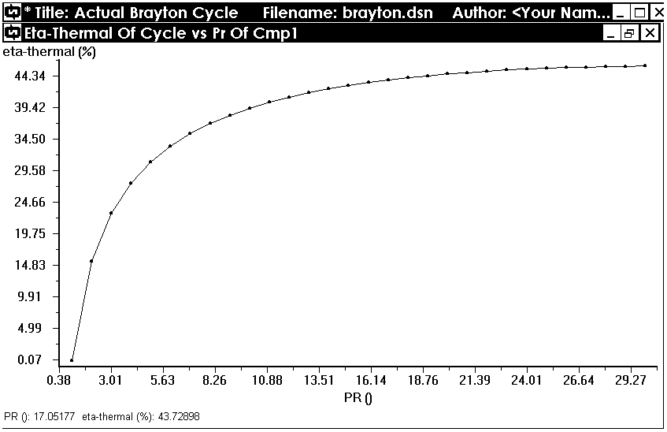
Figure 5. Actual Brayton Cycle, Effect of
Pressure Ratio on Cycle Efficiency.
efficiencies. Figure 8 is the same sensitivity analysis done on the split-shaft gas turbine. Figure 8 resembles the actual Brayton Cycle shown in Figure 7 and shows clearly that increasing the maximum gas temperatures in a gas turbine engine will increase the efficiency, but not for the same reason learned in physics.
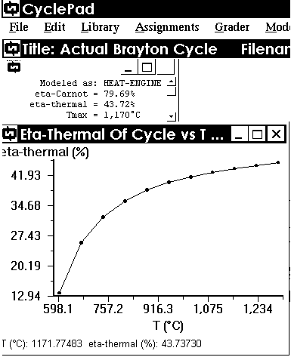Figure 7. Actual Brayton Cycle, Effect of the Heat Source
Temperature on Cycle Efficiency.
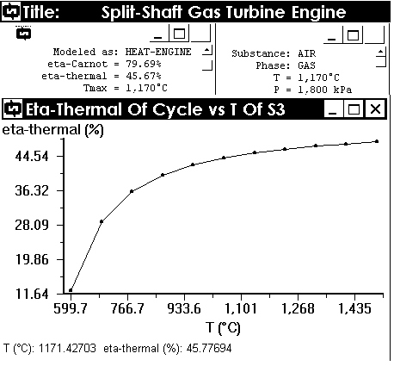 Figure 8. Effect of Turbine Inlet Temperature on Cycle
Thermal Efficiency, Split-Shaft Gas Turbine.

Planned ICAI

Textbook
Professors Wu and Tuttle are writing thermodynamics textbooks designed for courses that make full use of CyclePad for calculations. These include instruction on finding thermodynamic properties of a wide variety of working substances, First law and Second law analysis for control mass and control volume systems, and finally, thermodynamic cycle analysis. ICAI texts include most topics covered in conventional texts. Thermodynamics: A Computer-Based Approach is the first computer-based textbook of its kind written for thermodynamics courses.
This text was written to service two courses at the U.S. Naval Academy and is in the final publishing stages. It is expected to be available for one course in Fall Term, 2001. The first course is an elective for engineers. The second course is Naval Engineering for non-engineering majors at the Naval Academy. Other schools may offer a similar course in the core course category. Some schools require this course for NROTC. Therefore, the course and the textbook include sections on fluid flow, heat transfer and some example problems related to naval applications. Both courses require students to learn U.S. Customary Units (also known as English Units or the British Gravitational System).

Scheduled Courses
An elective course for engineering majors is scheduled for Fall Term 2001. The three-hour course, EM485D, Thermodynamics: A Computer-Based Approach includes a lab period and is open to students who have taken EM319 and who do not take EM320, applied thermodynamics.
Courses planned at the Naval Academy include traditional topics treated in thermodynamics plus cycle analyses on CyclePad. Engineering students, who do not take EM320, do not take heat transfer either. Applied thermodynamics courses for such students at the Naval Academy include small amounts of heat transfer and heat exchanger design. This is relevant because most heat engines and heat pumps/refrigerators include heat exchangers.
Another applied thermodynamics course at the Naval Academy, EM300. Naval Engineering II, EM300, is for students in non-engineering majors and it is well suited for using CyclePad. EM300 covers basically the same subjects as engineers get in two terms, but at less challenging levels. Students are required to understand thermodynamic principles and their applications. This course is calculation-oriented with a small amount of cycle-analysis introduced in lab sessions.
Changing courses creates pedagogical problems. The planned approach is to offer a substitute course, EM300C, to a few sections. Computer-based thermodynamics will be an improvement for these students. ABET required courses, such as EM319 and EM320, are longer-range goals for Intelligent Computer-Assisted Instruction, ICAI, at the Naval Academy. A design-based approach will help students understand thermodynamics and gain early design experience.

Conclusions
The only reason for teaching students to calculate a thermodynamic cycle is so they can use it as a math model for running experiments cheaply and easily. Computer models allow engineers to run experiments that otherwise would be impractical or impossible. “If all existing engineers had had computer programs to help with cycle analysis, more of what they know would be correct” (Tuttle and Lindler, 1989).
It is not enough to learn how to calculate temperatures after compression and expansion or the work required to compress the air or expand the hot combustion products in a turbine. The net work of a cycle and cycle thermal efficiency are traditionally the culmination of calculations on a thermodynamic cycle. None of these calculations tell a student or an engineer what will happen if compressor inlet temperatures decrease or increase. In order to see that decreasing ambient temperature decreases the compressor work, increases the net work and yet has no effect on the cycle thermal efficiency, a student must work a cycle’s calculations again. Once programmed, a computer can work cycle calculations as many times as desired and plot the results for visual effect.
Traditionally, engineering faculty members have not been able to work the analyses of heat engine cycles into thermodynamics courses. The cycle analyses processes are too laborious and too time consuming when done by hand - but not when done by computer. This is what computers were designed for. It is no more difficult to calculate a cycle a hundred times than it is to calculate a cycle once, for a computer. Every thermodynamics course needs to switch to computer-based thermodynamics in order to achieve the final step in thermodynamics, parametric analyses of the thermodynamic cycles.

Acknowledgments
The authors are grateful for support from ONR, Office of Naval Research, the Cognitive and Neural Science & Technology Division, Dr. Susan F. Chipman.

References
Baher, Julie. Articulate Virtual Labs in Thermodynamics Education: A Multiple Case Study. Journal of Engineering Education, October 1999. 429-434.
Tuttle, Kenneth L. and Keith W. Lindler. Thermodynamic Power Cycles Using Personal Computers. COED Journal, Vol. X, No.4, October 1990. 62-64.
Wu, C. Using Articulate Virtual Laboratories in Teaching Energy Conversion at the U.S. Naval Academy. Journal of Educational Technology Systems, vol. 26, 1997. 127-136.

