Supporting Student Design Work in Articulate Virtual Laboratories

Joyce Ma, Julie Baher, and Leo C. Ureel II
The Institute for the Learning Sciences
Northwestern University
Evanston, IL 60201

Abstract - An Articulate Virtual Laboratory (AVL) is educational software that allows students to create models in a virtual design space, permits students to simulate how that model will behave, and explains to students how and why their model behaves the way it does. To date, two examples of AVLs have been developed. The first, CyclePad, was designed for university engineering students and is being used by students to build thermodynamic cycles. The second, Feedback Articulate Virtual Laboratory (FAVL), was designed for high school students and is used by students to build feedback control systems. Designing an AVL to have pedagogical value requires a consideration of many factors -- pedagogical, motivational, and technical. This paper will describe the design rationale behind CyclePad and FAVL focusing, in particular, on the pedagogical supports designed into the software to help students create designs to allow them to explore the respective subject domains.

Introduction
Design activities are core to scientific and engineering practice and have been identified as both an educational goal and means in science and engineering education at the undergraduate and K-12 levels. The Accreditation Board for Engineering and Technology (ABET) now requires that undergraduate engineering education includes a strong design component (ABET, 1997). Likewise, the National Science Education Standards have identified design activities as a means of motivating learning of scientific content and process as well as a vehicle for understanding the technological world for K-12 education (National Research Council, 1996). Yet, providing design activities in the classroom can be particularly challenging. Design activities can require large amounts of time, material resources, and human capital. In many domains, cost and safety concerns prevent student participation in design work that would otherwise be both motivational and educational. Furthermore, design activities themselves are cognitively demanding for both instructors and students, requiring that the students be coached in content as well as strategies in an ill-structured problem space.

As computer resources become more available in schools, software tools may offer design opportunities that have, in the past, been inaccessible to students. In fact, there are already several examples of software that are useful in design work. These include: CAD systems that are now prevalent and indispensable to professional engineers, simulation packages such as MatLab and SimuLink that allow engineering students to build and simulate dynamic systems, interactive games such as SimCity that allow users to explore the workings of virtual worlds they themselves build, and model building software such as STELLA (Mandinach & Cline, 1994) and Model-It (Jackson, Krajcik, & Soloway, 1994) that allow pre-college students to build models of natural phenomena. Each of these types of design environments has made design activities more accessible to its users. However, in many cases, these programs do not, in and of themselves, provide coaching and scaffolding to help novices explain and make sense of their particular designs.

An Overview of the Articulate Virtual Laboratories
One of the research goals of the Articulate Virtual Laboratory Project is to explore how to use software to better support students in their design work and help them develop design skills and domain knowledge. Articulate Virtual Laboratories are designed to provide students with a tool that can make conceptual design tasks more accessible by giving them:

- A conceptual CAD tool that students use to generate and analyze their design.
- A test environment which provides a setting for students to run a simulation of their design.
- A set of visualization tools to help the student understand complex and dynamic relationships.

AVLs also provide explanations of the “how” and “why” of the science and interactions behind their designs (Forbus, 1997). An Articulate Virtual Laboratory (AVL), therefore, also provides the following software components:

- An analysis coach that helps students evaluate their designs.
- A design coach that makes suggestions for how a student's design might be improved.

To date, two different AVLs have been developed. The first, CyclePad was designed for university engineering students. The second, Feedback Articulate Virtual Laboratory (FAVL), was designed for high school students.

The CyclePad AVL
CyclePad was the first AVL developed and was designed to teach thermodynamics principles by allowing students to build thermodynamic cycles. Several different types of universities and engineering programs have been using CyclePad since 1996. CyclePad has assisted students in learning thermodynamics in lecture-based textbook teaching, open-ended design assignments, lab-based group work, and project work (Baher, 1998). Figure 1 shows the design environment for CyclePad.

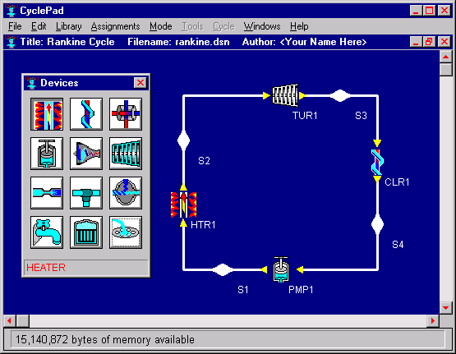
Figure 1. CyclePad design environment. Students can select devices from the Devices Window, add them to the blueprint area, and then link them together to build thermodynamic cycles (e.g., power plants, engines, and refrigerators)

FAVL – The Feedback Articulate Virtual Laboratory
FAVL was developed for high school students to teach about feedback control systems through engaging them in conceptual design activities. FAVL has been used with 26 students in a local high school as an experimental module within a project-based class, called Engineering SmartLab. Our work with high school students has formed the basis for redesigning FAVL as well as for understanding how students reason about feedback control through design activities. Figure 2 shows the FAVL design environment.

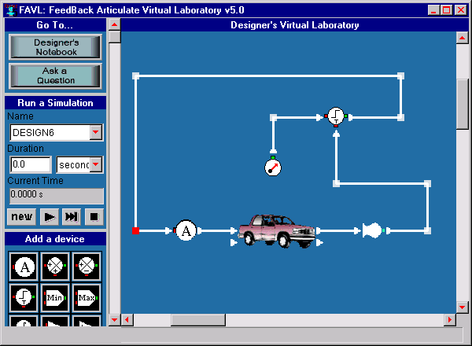
Figure 2. FAVL design environment. Students can select a device from the 'Add a device' panel on the left of the screen, add it to the blueprint area, and then draw connections to link one device to the next to construct a feedback control system. This figure shows a design for a cruise control system for a car. The devices represent functions that are typically found in feedback control systems.

Pedagogical Supports in AVLs
Pedagogical supports are systems or structures that are intended to help learners (often novices in a field) as they do their work. We differentiate these supports from other software features that are not specifically targeted at learners. For example, an expert in thermodynamics (such as a professor) could use CyclePad’s laboratory environment to build and analyze a cycle. The basic features that allow for cycle creation and analysis are necessary components of CyclePad regardless of the prior knowledge of the user. The pedagogical supports (such as the coaching systems) were designed to help students who are learning the domain and thus less able to effectively use the laboratory environment unaided.

What is design?
To better understand the supports that we have built into the articulate virtual laboratories, we first describe the conceptual design activities that students use these programs for. The word design in the educational improvement literature is used to refer to various types of activities. AVLs are designed in particular to help students with conceptual design problems that require the student to construct an artifact that meets a given set of functional requirements by combining more basic, available parts. In conceptual design the basic properties and parameters of the design are defined. For example, Figure 1 shows a design for a type of thermodynamics cycle (Rankine cycle) that is used in power plants. This schematic provides information about the necessary types of components (a turbine, heater, cooler and pump) at a general level. An actual power plant design would have much more complexity and specificity of parts.

A simple model of the design process is helpful to understand what types of design projects AVLs are appropriate for (see Figure 3).

Requirements Definition

Map requirement to design

Refine Requirements
Design Construction
Design Analysis
Select relevant components

Put together components
Simulate design behavior

Specify how the components should behave
Assess results against requirements

Figure 3. The Design Process

Requirements Definition- Design work can involve specifying design requirements in more detail or even renegotiating the overall design requirements with a client. Even if very detailed overall design requirements are given, for more complex design projects, a designer still needs to decompose these overall requirements into a simpler set of requirements that can be addressed one at a time as the designer works towards a complete solution. For example, in one of the FAVL design activities, students are asked to design a home heating control system that can keep the temperature in a house within a specified range throughout the year. Typically, to meet this requirement, the student would decompose the problem to two separate problems: 1) keep the house temperature below the maximum allowable temperature on hot days and 2) keep the house above the minimum allowable temperature on cold days. Then they reintegrate the solution to meet the overall requirements for the home heating design.

Design Construction -- Design construction encompasses a broad array of activities including specifying which components to use, determining the relationships between components, and modeling how each component or grouping of components should behave to meet the functional requirements. For AVLs, this process involves selecting the appropriate components for a design from a 'tools palette', determining their relationships to each other by drawing appropriate connections between components, and specifying often numeric values, the properties, or qualities, for the components chosen. For example, in CyclePad a student might choose components such as a turbine and a heater, order them so that the working fluid will be heated before entering the turbine, and, finally, input quantities for the amount of heat that will be added to the fluid and the state at which the substance will be in after exiting the turbine.

Design Analysis – After a design has been constructed, it needs to be tested to see if it meets the design requirements. This typically involves running a simulation to determine how the design behaves. If the design does not meet the requirements, then the designer may re-evaluate the requirements to determine if they were reasonable specifications or may make changes to the failed design . For example, once a student has created a design in FAVL s/he can run a simulation that will show an animation of how the design works and generate graphs of its behavior. (See Figure 4.) This output is then used to determine whether the design is performing within specifications.

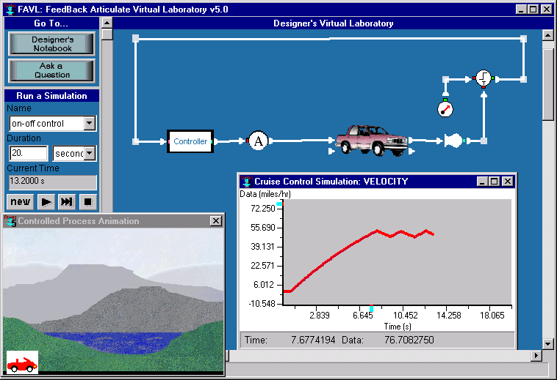
Figure 4. The results of a simulation run in FAVL. An animation window and graph show how well the cruise control design controls the velocity of a car.

Pedagogical Supports in AVLs
Articulate Virtual Laboratory (AVL) software tries to support students in the above set of activites as they work on design problems. In the following, we describe the support issues we are trying to address in CyclePad and FAVL.

Requirements Definition
Design problems are often characterized by multiple, and sometimes conflicting, constraints that need to be refined in the course of a design project. Although there is great educational and motivational value in allowing students to grapple with defining their own design specifications, this task can be particularly difficult for a novice. With AVLs, scaffolding the novice towards more open-ended problems is largely left as a curricular issue. For example, an instructor can choose to define the first set of design activities with very specific requirements and, as students gain more experience, provide more open-ended design problems.

Towards this end, our efforts in designing CyclePad have focused on providing professors a means of defining appropriate problems with varying constraints. Specifically, we have built into CyclePad an Assignment Builder that allows instructors to specify constraints for design problems. When students open a design problem file, they are presented with the CAD-style CyclePad interface that has an additional space for the assignment details. (See Figure 5.) This assignment information is always visible and available to the student throughout the design process. We have just begun to use this feature to develop a sequence of curricula that will lead students from simple problems up to complex design problems.

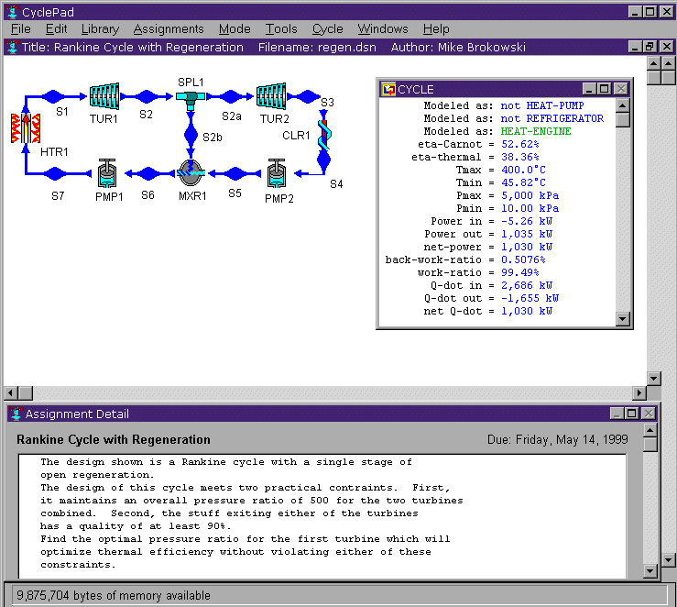
Figure 5. Assignment show in the lower window of CyclePad

In FAVL, we have created a set of design projects students can undertake with varying specificity of the design goal, and we rely on an instructor to sequence these designs within a curriculum. Within each design project, however, FAVL provides students with a plan that breaks down the problem into smaller parts with intermediate requirements to be met. (See Figure 6.) This plan is included as part of the background material found in a virtual Designer's Notebook that accompanies each design project. In addition, the background material contained in this Designer's Notebook is intended to help students interpret the design requirements by grounding the design project within a real world context they are familiar with. In this way, we hope to capitalize on prior knowledge that students may bring with them to understanding the design requirements.

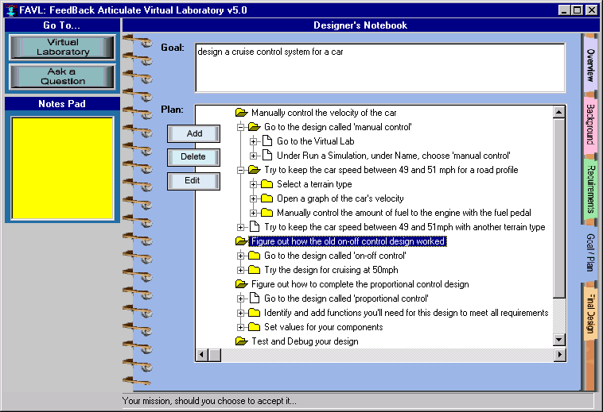
Figure 6. The Design Plan in the FAVL Designer's Notebook. This plan lays out the intermediate steps towards creating a cruise control system in the virtual laboratory.

Construction
One of the most difficult aspects of design is to synthesize from a set of component parts a system that satisfies the functional requirements of the system. AVLs have several types of pedagogical supports to help students construct designs.

Both CyclePad and FAVL attempt to help students select the appropriate component parts through various means. First, we have designed the components in both pieces of software so that they represent abstractions of functions or devices; this is to help focus students on key relationships and behavior instead of on less relevant features (such as a particular implementation of a part).

Also, we provide a limited toolkit of parts that can be used in their design work. For example, in CyclePad, a student can choose to work on an “open” or “closed” cycle. Depending on this choice a different set of components will appear. (See Figure 7). This choice can also be pre-set by the instructor when he creates an assignment using CyclePad’s assignment builder.

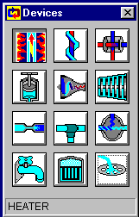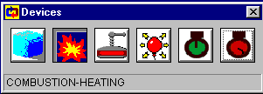
Figure 7. Component palettes for open (left) and closed (right) cycle design environments in CyclePad.
In FAVL the instructor can specify a subset of all the parts that are available for a design. As a student becomes more familiar with what each component can do, with each successive design project, the instructor can make more parts available to the students.

To help students determine what each part is, FAVL also provides descriptions of each component (Figure 8). As in CyclePad, students can also annotate each component in their design to help them articulate what they believe each component is doing in their design.
Figure 8. Component properties description in FAVL. For each component, a student can bring up a pop-up window that describes all the properties associated with that component. This figure shows the properties associated with the car in a cruise control design.

To help students map functional requirements to components, CyclePad and FAVL provides various forms of coaching. In CyclePad a teleological reasoner, called CARNOT, can inform students what functional role each component plays in a design (Everett, 1995). (See Figure 9.) Students can also request help on improving their design by using an e-mail coach. When they send a request to the email coach their current design is automatically sent to the CyclePad Guru agent. The agent software processes the design, comparing it to a library of alternative designs, and selects some possible improvements. The Guru agent will then send an email back to the student with pointers to relevant design improvement ideas on our CyclePad Web library (see http://www.qrg.ils.nwu.edu/thermo/design-library/). More details about this aspect of coaching can be found in Forbus, et al. (1998).
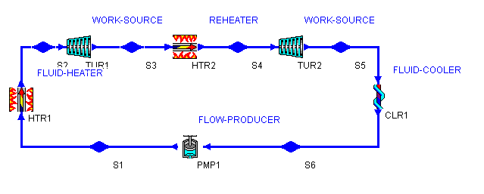
Figure 9. Device Role Annotations show students how components function within a CyclePad design.

In FAVL, the software can check a student's design to determine if the basic functional parts have been included and connected in the design. Students can ask the built-in coach, "How can I improve my design?" for recommendations on what to include or exclude in their feedback control system design (Figure 10). When composing an answer, the coach first checks to make sure the student's design has the basic functional components required in all feedback systems. If a basic component is missing, the coach suggests that the student includes this missing component in the design. The coach then compares the student's design to a library of five canonical controller designs and if the student's design is similar to one of these, the coach will make additional recommendations towards adding appropriate components to help the student complete the design.

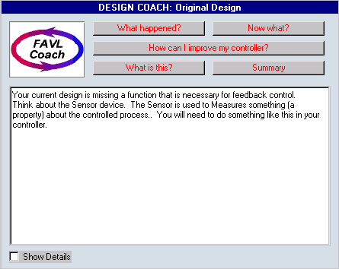Figure 10. The Design Coach in FAVL. In this case, the design coach is suggesting that the student add a certain component to the design after a student asks, "How can I improve my controller?"

Design Analysis
To analyze their designs, students need a tool that can simulate the behavior of their design and help them interpret this behavior in light of the design requirements. To help students in their analysis, AVLs provide a test environment in which student can 'run' their designs to simulate behavior.

Furthermore, the AVLs provide explanations of each simulation run. Specifically, both AVLs use qualitative explanations in conjunction with numerical plots to help students analyze what happened in their designs. The use of qualitative explanations is motivated by studies by deKleer & Brown (1984) and Larkin (1980) which indicate that experts typically use qualitative reasoning to understand a problem. Furthermore, a purely numerically based approach to solving problems may actually hinder the development of a deeper conceptual understanding because quantitative analysis can obscure causal relationships (White & Frederiksen, 1990). The AVLs use qualitative explanations to help students can find out how numerical values were derived, what the consequences of design assumptions are, and why the design acts the way it does.

For example, to help students explore inferences and numerical values, CyclePad generates explanations linking shown values to student assumptions and fundamental thermodynamic relations. (See Figure 11.) The text in the explanation windows is built directly from CyclePad’s underlying knowledge base. Students access this by clicking on a value and selecting a question (as shown in Figure 11). This brings up the Explanation Window where the student can explore further.

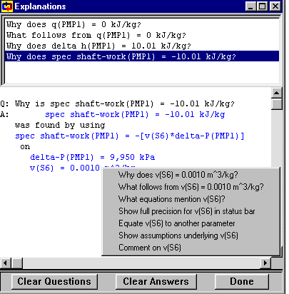

Figure 11. CyclePad's explanation window. The student can click on blue hypertext to ask questions about how values were derived.

In FAVL, a student can ask the software coach, "What happened?" to obtain a qualitative explanation of why the controlled process behaved the way it did. In addition, to help students interpret the systems' behavior in light of the requirements, the FAVL coach evaluates the behavior against the overall design specifications and in this way helps students make the connection between their design behavior and design requirements. (See Figure 12.)

(a)The coach describe qualitatively how the velocity is changing during the simulation run of a cruise control system after a student has asked, "What happened?"
(b)The coach indicates if the design meets the requirement after a student has asked, "How can I improve my controller?"
Figure 12. The FAVL Coach. The coach can provide explanations to help students in analyzing their designs.

Discussion
Throughout the AVL Research Project, we have been observing how students use our software and have been making appropriate improvements to our software based on these observations. This ongoing process of iterative design continues to shape the types of supports that we see as necessary to help students in doing design work. Below we present some of our observations on students' use of the existing pedagogical supports.

Requirements Definition
Engineering students using CyclePad have little trouble understanding design requirements as their knowledge of thermodynamics and terminology increases. Professors who are experienced with using CyclePad in their courses often introduce terminology earlier in the term than usual so that students will be able to understand its use in CyclePad.

High school students using FAVL also seem to have few difficulties understanding the design requirements given in their design projects. However, it can be difficult for some students to stay on task even if they initially understand the design requirements. That is, they often lose sight of the overall design requirements when they use FAVL. This was also the case despite our attempts to simplify the problem space by giving students intermediate requirements to meet. Students would start on these requirements, become lost in the mechanics of creating a design and seem to forget what they were supposed to be doing.

Yet, for other high school students working with FAVL, they would not only stayed on task, but would try to refine the given set of design requirements after meeting these original requirements. For example, some students in their initial design of a home heating control system would turn both the heater and the cooler on to keep the house above a minimum temperature in winter. Even though this design can meet the given requirements, some students would reformulate the given design specifications and add additional constraints (i.e., the cooler cannot be turned on in the wintertime) to include their own ideas of what makes an efficient design.

Design Construction
After students learn the mechanics of how to use the specific design environments, they have little trouble manipulating icons. With CyclePad, construction helps make visible to students the underlying thermodynamic concepts and their inter-relationships. In previous studies, some students found that the structured design approach helped them with their problem solving skills. That is, because CyclePad forces students to be explicit about their modeling assumptions students became aware of the steps necessary to solve design problems (Baher, 1998).

For high school students using FAVL, it can be particularly difficult to understand what each component does let alone how the components fit together in a larger design. Initial analyses indicate that students have problems understanding what is being represented with the functional blocks used in FAVL. A case study suggests that it can take students a few class periods before they begin to differentiate the functions represented and then reintegrate these functions into a complete design (Ma, submitted).

Although the design coach should help the students, not enough students, using either FAVL or Cyclepad, use the design coach for suggestions. We hypothesize several reasons for this:

- Coaching help in AVLs is “on demand” rather than a more intrusive style such as is often employed in other intelligent tutoring systems. Thus, students may be confused yet not ask for help.
- Students may be unaware or forget that these coaching features exist in the software. For example, often when an instructor teaches students how to use the CyclePad software, they show a solution path to solving the problem without showing the students what resources are available to get around a possible trouble spot.
In several ways, CyclePad helped make visible to students the underlying thermodynamic concepts and their inter-relationships. Some students found that the structured design approach helped them with their problem solving skills. By being forced to be explicit about their modeling assumptions students became aware of the steps necessary to solve design problems (Baher, 1998).

Design Analysis
Students have little problem learning to make simulation runs and interpret the results in light of the overall system requirements. However, we found it necessary to encourage students to reason more deeply about the results of their simulation runs. For example, in introductory thermodynamics courses, we include questions into the curriculum about the designs that require students to explore other design options or require them to explain how certain values were derived. Thus, in essence, we “force” students to use the explanation system in analysis. Ideally, problems would lend themselves to this type of inquiry naturally but we have yet to achieve that ideal with novice students. For students in more advanced courses where they use CyclePad to do project work, in-depth analyses are more natural.

Although high school students using FAVL can easily run simulations, they rarely take the next step to understanding why the design did not perform as expected. Analysis for these students seem to stop at 'does it or does it not work,' and students need to be prompted repeatedly to look more closely at individual parts of their design and to reason about their design to determine what may be wrong. We have only recently implemented the analysis coach in FAVL. Yet, initial observations indicate that the analysis coach is rarely used in the course of student design work. We have yet to determine why this is the case.

Conclusions
Through our collaboration with faculty, surveys of students and classroom observations, we have gained an understanding of how AVLs have helped students learn engineering principles. From this data we are beginning to understand how the pedagogical supports in AVLs help students learn and where they fall short.

Designing supports that effectively helps students do design projects is a complex task. Several levels of scaffolding must be well integrated into a program to help students at all phases of design work. As designers, we can build facilities that can offer students a rich array of information. Yet often students will not use these impressive features. Creating supports that are both pedagogically sound and practically useful remains a challenge.

Acknowledgements
This research is supported by the Applications of Advanced Technology Program of the National Science Foundation. The authors would like to thank Ken Forbus for his thoughtful review of this paper. Special thanks to the thermodynamic professors and students and the high school teachers and students who worked with our software and participated in our research project.

References
Accreditation Board for Engineering and Technology. (1997). “Engineering criteria 2000.” http://www.abet.org/EAC/eac2000.html.

Baher, J. (1998) “How Articulate Virtual Labs Can Help in Thermodynamics Education: A Multiple Case Study.” Frontiers in Education 1998 Conference, Tempe, AZ, 663-668.

deKleer, J., & Brown, J.S. (1984). A qualitative physics based upon confluences. Artificial Intelligence, 24, 7-83.

Everett, J. O. (1995) “A theory of mapping from structure to function applied to engineering domains.” Fourteenth International Joint Conference on Artificial Intelligence, Montreal.

Forbus, K. (1997). “Using Qualitative Physics to Create Articulate Educational Software.” IEEE Expert, May/June, 32-41.

Forbus, K., & Whalley, P. B. (1994). “Using Qualitative Physics to Build Articulate Software for Thermodynamics Education.” Proceedings of the 12th National Conference on Artificial Intelligence.
Forbus, K. D., Everett, J. O., Ureel, L., Brokowski, M., Baher, J., & Kuehne, S. E. (1998) “Distributed Coaching for an Intelligent Learning Environment.” Qualitative Reasoning: The Twelfth International Workshop, Cape Cod, MA, 57-64.
Jackson, S.L., Stratford, S.J., Krajcik, J., & Soloway, E. (1994). Making dynamic modeling accessible to precollege science students. Interactive Learning Environemtns, 4, 233-257.
Larkin, J.H., McDermott, J., Simon, D.P., & Simon, H.A. (1980). Expert and novice performance in solving physics problems. Science, 208, 1335-1342.

Ma, J. (submitted) “A Case Study of Student Reasoning About Feedback Control in a Computer-Based Learning Environment" Frontiers in Education 1999 Conference.
Mandinach, E.B., & Cline, H.F. (1994). Classroom dynamics: Implementing a technology-based learning environment. Hillsdale, NJ: Erlbaum.
National Research Council (1996). National science education standards. Washington, DC: National Research Council.
White, B., & Frederiksen, J. (1990). Causal model progressions as a foundation for intelligent learning environments. Artificial Intelligence, 24, 99-157.

